Code Reviews

A Step-by-Step guide to a better world by Manuel M. Huber

Code reviews are a widely spread practice in software development to ensure high code quality and one of the cheapest ways to find and fix bugs. Like “Agile Development” there is no “one correct way” to do it but many of the biggest companies like Google have some form of Code Review deeply integrated in their core process of software development. If you don’t do code reviews already you should.
Here’s how you can go about getting started with code reviews in your projects:
- Win Hearts and Minds
  - Inform your team / manager of the benefits of code reviews
  - Address existing doubt and criticism
  - Ensure your team wants to do code reviews
- Set your Goals
  - List & prioritize your goals as a team
  - Automate & delegate as many of these items as possible
- Define a process
  - When do we review?
  - How do we review?
  - Who reviews?
  - What do we review?
- Do it!
  - Teach Best Practices
  - Avoid common pitfalls
  - Reflect & adapt your process

Step 1: Win Hearts and Minds

You’ll need the support of the developers to ensure code reviews are carried out with the necessary amount of diligence. But you’ll also need the support of your manager and or customer since they will be paying for the time required to review code.
You can convince a lot of developers of code reviews by telling them “That’s what they do at Google!”. If this doesn’t work, try the following:
- You no longer have to worry about being solely responsible for breaking something – somebody else reviewed it and also thought it was ok!
- You no longer have to worry about that one co-worker messing up your code base – somebody is going to review it first!
- Reviewing code is like refactoring – but instead of you refactoring old legacy code you just tell the author to refactor it themselves before it becomes legacy code!
- You can show off your fancy coding skills and learn a new trick or two yourself!
Code Reviews don’t actually create more work – they just make sure the work is being done right now, while everybody still knows what and why it does what it does - instead of a year down the line when it is considered “legacy code”. There’s no easier way to
- Improve Code Quality (thus reducing the need to refactor later)
- Find bugs (and fix them right away)
- Share knowledge of the code base
- Help new team members learn and contribute
Your manager or customer is probably going to want to see some numbers. The benefits of the developers still apply to them as well (since developer time is money) but they probably need some graphs and numbers to justify the investment. Show them the page “The price of Quality”
Answer these common objections if they arise:
- “It slows us down too much”
  - While review adds time to each feature the reduced error rate cause release cycles to shorten
- “It’s too expensive”
  - It saves money in the long run - either pay now or pay later with interest
- “It causes friction between developers”
  - We can teach how to properly comment on code (“Don’t criticize but discuss”)

The Price of quality

Code quality is never free. You can either pay it now or pay with interest.
While the investment in code quality doesn’t return immediately it will pay off in the long run. So-called “Technical Debt” (caused by low quality code) increases the cost of every bugfix and new feature since a low-quality code base makes changes and additions more difficult and time consuming. One of the cheapest ways to pay of this debt is to do so right away: During a Code Review a second developer looks over the code to spot any mistakes before the software goes into production or even QA.
Several case studies with significant project sizes have shown that regular code reviews are one of the most effective ways to improve software development.
One study calculated the savings on a project of 10 developers and about 10.000 lines of code. They sent the project to Quality Assurance (and subsequently customers) once without internal reviews and once after being reviewed by another group of developers first. From previous similar work they know the average cost to fix depending on when a bug is found. The result was that the reviews not only halved the cost of bug fixes but also delivered a vastly more bug-free product to customers.
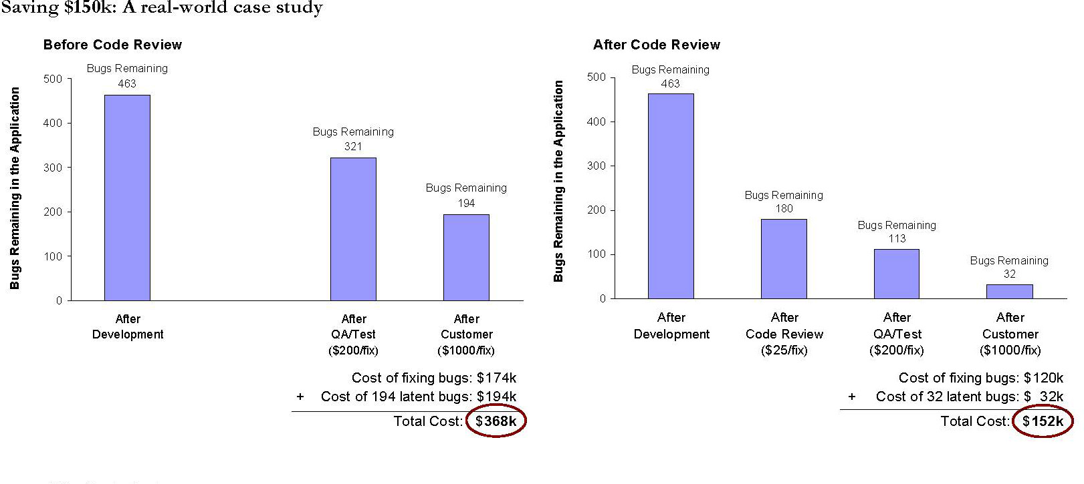Many big companies, like AT&T, IBM and Google introduced some form of code review and have found that error rates drop by up to 90%.
Besides the financial benefits code reviews also:
- Spread knowledge throughout the team making personal changes less troublesome
- Make on-boarding new developers easier
- Shorten release-cycles due to reduced bugs

Step 2: Set Goals

Gather your dev team and list all of the aspects that are important to you (use the list below as inspiration). Then see which of these you can accomplish without reviews. Automate as much as possible.
Many of these items require something else first. To automate code style checks (“linting”) your probably need a Continuous Build/Deployment/… server. To ensure a consistent architecture you’ll need an explicit architectural design and so on.
You should probably have:
☐ CX server with code-quality tools
☐ style guide (make use of existing guides!)
☐ architecture design
☐ Dos and Don’ts list
Here is a non-exhaustive list of things to consider:
- bugs
- code style (formatting, naming, …)
- readability / maintainability
- architectur (single responsibility, dependency inversion, interface design, package structure, …)
- code conventions (Do you have Util classes? Where and how are constants defined? … ?)
- best practices (specifically for your project / languages / technologies / … )
- functional correctness (all requirements fullfilled? Edge Cases checked?)
- UI-Design
- test coverage (all critical aspects tested? Code quality of the tests good?)
- security / legal requirements
- performance
- documentation
The goal of this step is to
- Make code quality present in everybodies mind
- Have benchmarks of quality explicitly written down
- Set up other (automated) ways to reduce menial tasks during reviews

Step 3: Define your Process

Now you should write down how you’re going to review. The most common method are regular tool-based reviews but like with agile there’s no “one way”. Feel free to mix and adjust these methods as you need.
At the end of this step you should have a process diagram that explicitly shows every step of the review process and can be understood by new employees without the need for any explanation.

When & what to review?
The decision about when to review which piece of code is one of the most fundamental of the entire process. Since Code Reviews are such a great investment you should try to get your team to commit to as much review time as possible – preferably a regular review integrated with your regular process.
On-Demand Review
You review a specific piece of software when there’s a significant reason: A team member feels the quality of this code is particularly low, it’s critical to the core use case of the software or the author asked for a review.
- Low amount of time investment  - Improves quality of critical areas | - Only a small portion of code is reviewed  - Many defects will go by undetected

Random Review
Every developer has a set amount of time per week/sprint/… reserved for reviews and picks the code to review at will.
- Costs are very predictable  - Even the chance of being reviewed causes developers to write higher quality code | - Certain parts of the code may never be picked for review  - Can cause tension between developers

Regular Review
The review is an integral part of your development process. Most commonly this is done with git-branches where new code is only ever merged into the master branch (never directly pushed) and a merge is only allowed after a successful review.
- Highest error detection rate  - Review efficiency improves rapidly through constant reviews  - No unreviewed code | - Highest amount of time invested

How to review?
The decision about when to review which piece of code is one of the most fundamental of the entire process. Since Code Reviews are such a great investment you should try to get your team to commit to as much review time as possible – preferably a regular review integrated with your regular process.
Group Review
The team members prepare the code beforehand and discuss it in a moderated meeting. Often members will have a different role and present their findings which are then recorded.
- Very thorough  - Great to address code issues that are caused by multiple people | - Extremely expensive  - Disrupts the workflow of the entire team

Over-The-Shoulder Review
The author explains the code to the reviewer who is either physically looking over his shoulder or via a shared screen. The reviewer gives notes and issues are fixed immediately or directly after the review. After the review the author decides when the code is ready.
- Fast and simple process  - Discussions can be solved instantly  - Good way to teach and learn | - Author guides the review which might cause defects to be missed  - Both author & reviewer need to be present simultaneously  - Hard to track and enforce

Round-Robin / Tool-assisted Review
The author checks the code into a review system (often included in the VCS) and a reviewer reviews it when convenient. Most tools allow discussions to be attached to specific code locations. Multiple change-review-iterations can take place. The review is only done when the reviewer accepts the proposed code.
- Thorough and traceable process  - Many tools offer great functionality and integration with existing infrastructure | - Multiple rounds can significantly extend development duration

Pair Programming
While not technically a review type this can be especially effective when teaching unexperienced developers since instead of having to work through tons of comments you can ask & answer questions instantly.
- Foo | - Bar

